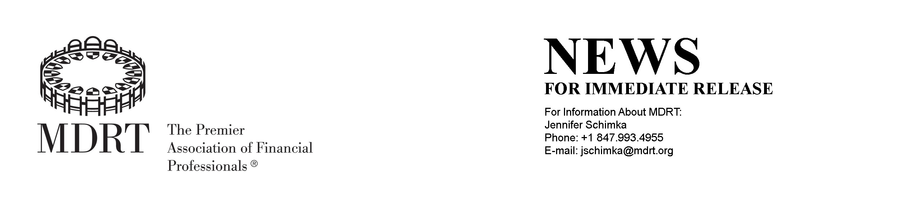

Local Interest: Greulich Qualifies for Prestigious "Top of the Table"

PARK RIDGE, ILL. – Outstanding client service, ethics and professionalism have elevated Robert Greulich of Oak Brook, IL to qualify for the exclusive "Top of the Table" of the Million Dollar Round Table — The Premier Association of Financial Professionals.® Greulich is a 10-year MDRT member and a 6-time Top of the Table qualifier.

Top of the Table status is the highest level of MDRT membership and places Greulich among the top professionals in the global life insurance and financial services industry. It recognizes Greulich for demonstrating exceptional professional knowledge, client service and ethical conduct.

"Attaining Top of the Table membership in MDRT is a distinguishing career milestone reserved for a select few like Robert who have proven that they are among the best of the best," says MDRT President, Michelle L. Hoesly, CLU, ChFC. ""We
are fortunate to have a talented and involved membership that helps MDRT to continue to be recognized as the global leader in financial services.""

In addition to recognizing career accomplishments, Top of the Table membership offers Greulich the opportunity to further improve professional skills by sharing ideas and best practices with other leading professionals at the Top of the Table Annual Meeting and other educational forums.

For more information, contact Greulich at 630 684 8562 or robert.greulich@thepinnacleplanninggroup.com.

ABOUT MDRT

Founded in 1927, the Million Dollar Round Table (MDRT), The Premier Association of Financial Professionals, is a global independent association of more than 38,000 of the world's leading life insurance and financial services professionals from more than 450 companies in 74 countries. MDRT members demonstrate exceptional professional knowledge, strict ethical conduct and outstanding client service. MDRT membership is recognized internationally as the standard of excellence in the life insurance and financial services business.

Million Dollar Round Table 325 West Touhy Avenue Park Ridge, IL 60068 USA
Phone: +1 847.692.6378
Fax: +1 847.518.8921
USA Web site: www.mdrt.org

